**The Abstract:**

SOFTWARE FOR PRELIMINARY CALCULATION OF THE POWER SUPPLY SYSTEM OF A SPACECRAFT

**SYMBOLS AND ABBREVIATIONS**

In the abstract the following designations and abbreviations with the appropriate transcription and / or explanations:

|  |  |
| --- | --- |
| Designation,  abbreviation | Transcript and/or explanation |
| AB | Accumulater battery |
| EPS | Electrical Power System |
| OBTS | On-board target system |
| OSSS | Occupational safety standards system |
| ECPM | Estimated-calculated parametric model |
| SB | Solar battery |

**Syzdykov Arman Bazarbayevich**

**Askaruly Rustam**

**Baktybekov Kazbek Suleimenuly**

**Sakhanov Kanat Zhaksylykovich**

**Object creation date: 23. 03. 2023**

**Scope of application**

Software for calculating the power supply system of a satellite, which will be the basis for the design of the power supply system of real spacecrafts.

**Destination**

The program allows to estimate and calculate the characteristics of the power supply system of the remote sensing system based on the parameters and characteristics of the components of the spacecraft equipment.

**Functionality**

Supporting systems (SS) are designed to support the operation of special systems and the satellite as a whole and include three groups: the electrical power system (EPS), the thermal mode support system (TMSS), and the onboard control system (OCS). The coordination of special and support systems is a special design task that is often overlooked by novice designers. This is part of the overall task of space system coordination, which includes, in addition to the spacecraft, ground facilities.

The main components of the power supply system of a spacecraft are a solar panel, a charge-discharge device, and a battery. Before proceeding to creation of software for preliminary calculation of the satellite power supply system, it is necessary to develop its mathematical model. The mathematical model of the satellite power supply system includes:

- a mathematical model of satellite motion in orbit;

- a mathematical model of the solar cell;

- mathematical model of the battery pack;

- mathematical model of a charging and discharging device.

Based on the developed mathematical models, it is necessary to develop algorithms for the functioning of each component of the power supply system. Using the obtained algorithms, we can proceed to the implementation of software for preliminary calculation of the power supply system of the satellite.

Estimated-calculated parametric model (ECPM) is designed to evaluate the power supply system, which is designed to provide electric power at direct current to the service equipment and payloads of the spacecraft at all stages of flight operation and at the stage of ground tests.

The choice of the instrument composition and determination of the characteristics of the EPS is made on the basis of the operating conditions of the spacecraft and the level of consumption of on-board systems. In this case, in general, the structural structure of the EPS remains unchanged and includes:

-primary power sources (solar panels);

-secondary energy sources (chemical batteries with service automation);

-voltage stabilizers.

The input parameters are the main characteristics of the spacecraft (SC) EPS components: the power consumed by the SC, the orbit parameters, the time of operation of the OBTS. Output (estimated) parameters are parameters of EPS performance - calculation of design power of EPS, estimation of parameters of SB and AB. Intermediate output parameters include:

- selection of the AB type,

- choice of SB type,

- degradation factor.

The proposed software allows the calculation of the power supply system.

The data necessary for calculations are taken from the submitted bids for the remote sensing system of the Republic of Kazakhstan and entered into the software.

* **Parameters affecting the power supply system:**
* - orbital altitude;
* - orbital period;
* - time of being in the shadow;
* - maximum power of spacecraft;
* - power in standby mode;
* - flight operation time;
* - degradation factor;
* - SB disorientation angles;
* - specific mass of SB;
* - reserve coefficient;
* - rated voltage;
* - discharge depth factor;
* - SB EFFICIENCY;

- AB EFFICIENCY.

* **Initial data:**
* **-** spacecraft orbit parameters (altitude, inclination);
* - orbital period;
* - maximum power of the spacecraft;
* - power in standby mode;
* - time of being in shadow,
* - nominal voltage.
* **Calculated data of the system:**
* **-** average power of the SC SES;
* - SB power;
* - design power of SB;
* - SB area;
* - SB mass;
* - permissible depth of discharge;
* - design capacity of the AB;
* - AB capacity.

**Calculation dependencies used in the software product**

**Spacecraft power calculation tab**

Figure 1 shows the tab for calculating the power of the spacecraft.

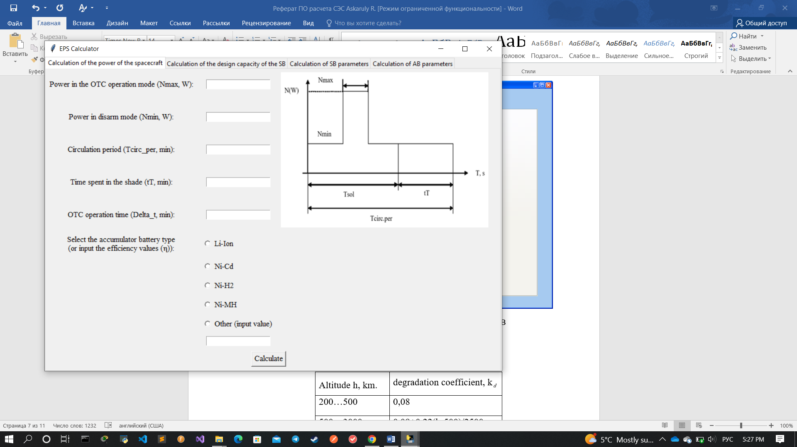

Figure 1 - Calculation of spacecraft power

Initial data:

* power in OTC operation mode (N, W);
* power in disarm mode (N, W);
* circulation period (T, min);
* time in shade (t, min);
* operation time (Δt, мин);
* AB efficiency (, %) ;

Output data:

* average power of solar power plant (N, W);
* capacity of solar batteries (N, W);

Calculated dependencies [1]:

**Design capacity calculation tab SB**

The tab for calculating the design capacity of the SB is shown in Figure 2

Input data:

* orbital altitude (h, km);
* time of flight operation (t, year);
* SB disorientation angles (, , degree);
* power of solar batteries (N, W);

Output characteristics:

* degradation coefficient (k);
* design power of the SB (N, W);

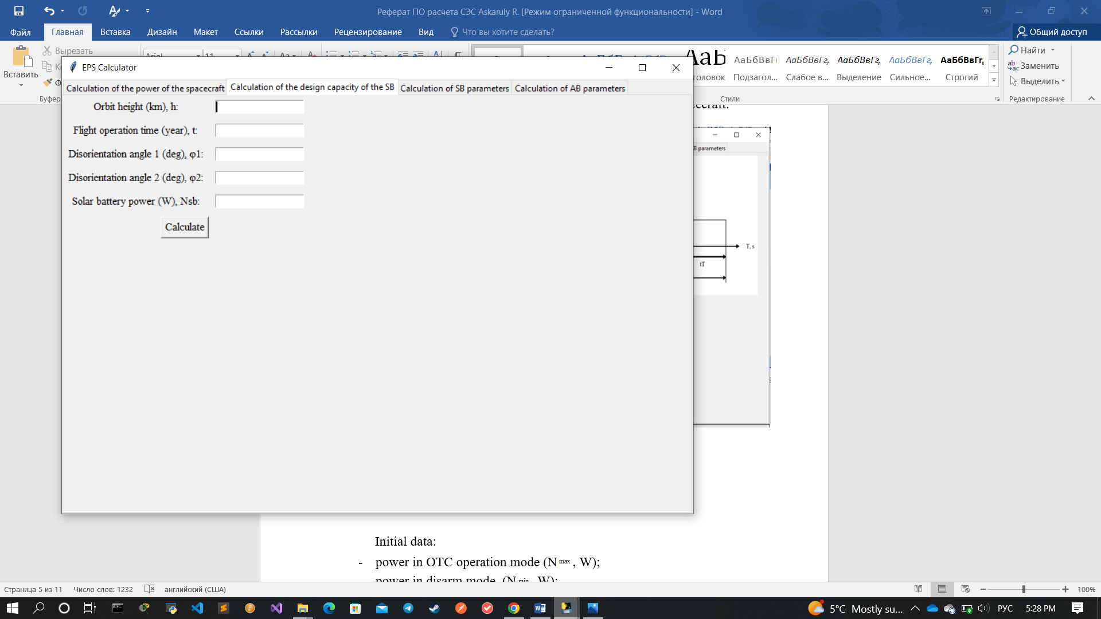

Figure 2 - tab for calculating the design capacity of the SB

Calculated dependencies in table [2]:

|  |  |
| --- | --- |
| Altitude h, km. | degradation coefficient, k |
| 200…500 | 0,08 |
| 500…3000 | 0,08+0,22(h-500)/2500 |
| 3001…36000 | 0,3-0,1(h-3000)/17000 |
| More than 36000 | 0,1 |

The tab for calculating SB parameters.

The tab for calculating the SB parameters is shown in Figure 3.

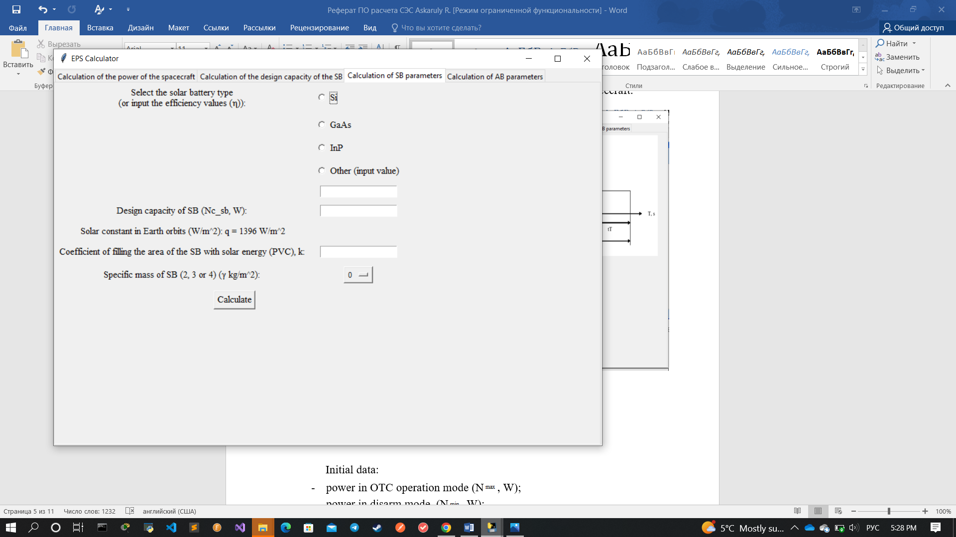

Figure 3 - SB parameters calculation tab

Input data:

- solar converter efficiency (, %);

- design power of the SB (N, W);

- solar constant at Earth orbits (q=1396 W/m);

- coefficient of filling the SB area with PVCs of solar energy (к);

- specific mass of the SB ( kg/m);

Output data:

- SB area (S m);

- SB area including losses (Sm);

* mass of the SB (M).

Расчетные зависимости [1]:

**The tab for calculating the parameters of the AB.**

The tab for calculating the parameters of the AB is shown in Figure 4

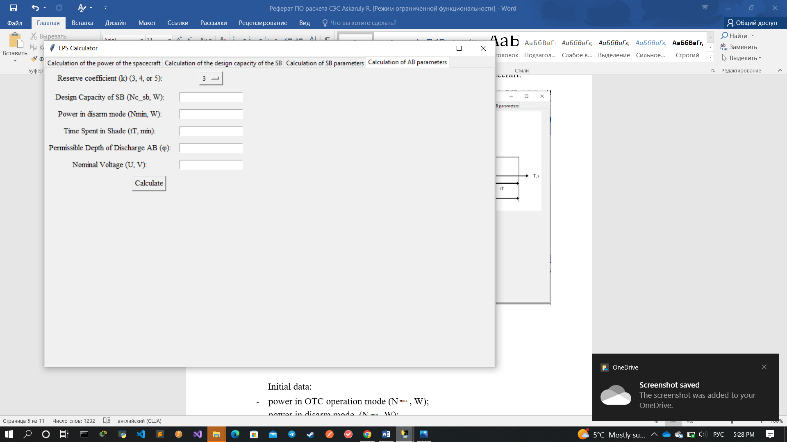

Figure 4 - AB parameters calculation tab

Input data:

* design power of the SB (N, W);
* power in disarm mode (N, W);
* time in shade (t, min);
* reserve coefficient (к);
* permissible depth of AB discharge ();
* nominal voltage (U, V)

Output data:

* design capacity of the AB (Е, Wh);
* permissible depth of discharge (Е, Wh);
* AB capacity (C , Wh).

To enter the data it is necessary to open the main file "EPS_Calc". In the open application, select the first tab and enter the data - to do this, select the type of AB and in the white cells enter the initial parameters to start the calculation. Press the "Calculate" button - the results are displayed in green cells, and intermediate data are displayed in yellow cells. Similar operations are performed with all tabs.

**Main technical characteristics**

* **Program size:** 30 MB
* **Overall dimensions:** 680x480
* **Resistance of technical and software tools:** This program is easy to use for both beginners and experienced users of various platforms. To use this program, you only need to install libraries, you can see in the first few lines on the code. Or you can convert this code to the “.exe” file with **“auto py to exe”** converter, you can read full information on the [**www.python.org**](http://www.python.org)**,** after that, you can create filename such **“EPS_Calc.exe”**, and go to the "**.exe**" file called "**EPS_Calc**", and you will have 4 tabs in the program window, each of them calculates what is indicated on the tab header, so it will be easy for you to navigate. Also, if your program does not work, which is very unlikely, try downloading the library via the command prompt or console, by writing the command **"pip install tkinter"**, the program will work after that.
* **Minimum system requirements:**
  + OS: Windows 7
  + Processor: Any
  + RAM: 64 MB
  + Graphics Card: Any
  + Disk space: 30 MB
  + Sound Card: N/A

**Programming Language**

The software is implemented in Python as a complete application.

**Type of implementing computer**

Works on all platforms, such as Windows - 64-bit x86, 32-bit x86; MacOS - 64-bit x86; Linux - 64-bit x86, 64-bit Power8 / Power9.

The calculated dependencies of the mathematical model were taken from the following sources.

1. Patel, Mukund R/, 1942 - Spacecraft power system / Mukund R/ Patel / p. cm. Includes bibliographical references and index. ISBN 0-8493-2786-5 (alk. paper)
2. Петровичев М.А., Гуртов А.С. Система энергоснабжения бортового комплекса космических аппаратов: учеб. пособие. - Самара: Изд-во Самар. гос. аэрокосм. ун-та, 2007. - 88 с.: ил.